STLC Workbook

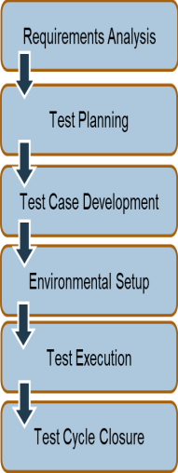

| Entry  Criteria |  |
| --- | --- |
| Exit  Criteria |  |

**Requirements Analysis**

**Requirement Types**

| Functional |  |
| --- | --- |
| Non-functional |  |
| Requirements Traceability  Matrix (RTM) |  |

**Requirements Analysis Stage Detail**

| Entry Criteria | Activity | Exit Criteria | Deliverables |
| --- | --- | --- | --- |

**Test Planning**

Types of Testing

**Requirements Analysis Stage Detail**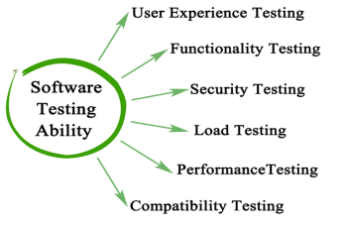

| Entry Criteria | Activity | Exit Criteria | Deliverables |
| --- | --- | --- | --- |

04

**Test Case Development**

| Test Case |  |
| --- | --- |
| Test Data |  |

**Test Case Development Stage Detail**

| Entry Criteria | Activity | Exit Criteria | Deliverables |
| --- | --- | --- | --- |

**Test Environment Setup**

| Test  Environment |  |
| --- | --- |
| Most important  thing about a test environment |  |

**Test Execution Stage Detail**

| Entry Criteria | Activity | Exit Criteria | Deliverables |
| --- | --- | --- | --- |

**Test Execution**

| Smoke Test |  |
| --- | --- |
| Regression Testing |  |

**Test Environment Stage Detail**

| Entry Criteria | Activity | Exit Criteria | Deliverables |
| --- | --- | --- | --- |

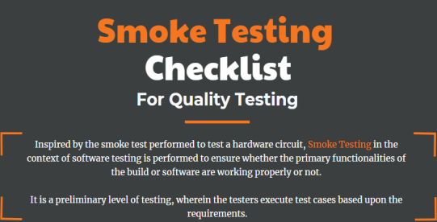

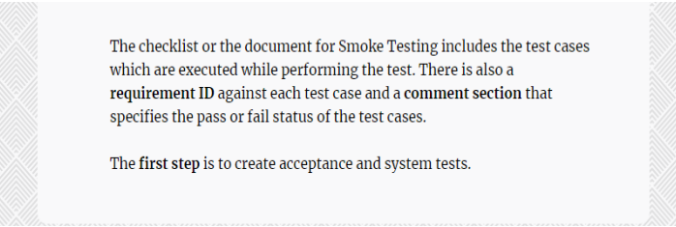

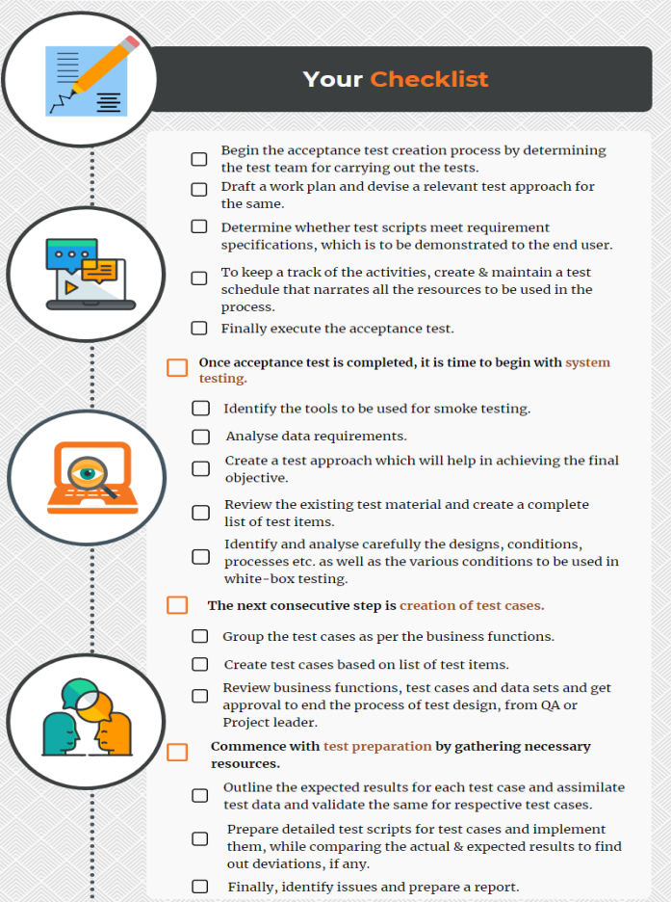

**Test Cycle Closure**

Test Cycle Closure Stage Detail

| Entry Criteria | Activity | Exit Criteria | Deliverables |
| --- | --- | --- | --- |